**ELECTRICITY BILLING**

**AIM:**

To draw flowchart and algorithm for the following problem

**ALGORITHM:**

Step 1: start

Step 2: read number of units consumed as N

Step 3: check condition if n<=100

Step 4: if condition is true , display no current charge

Step 5: check condition if n<=200

Step 6: if condition is true, for 100 units no charge and to calculate energy charge for remaining units then use the formula 1.5*(N-100)

Step 7: check condition if n<=500

Step 8: if condition is true, for 100 units no charge and to calculate the energy charge for 101-500 units, then use the formula 3.5*

Step 9: check condition if n>500

Step 10: if condition is true, for 100 units no charge

For unit 101-200 units, energy charge = 100*3.5 = 350

For unit 201-500 units, energy charge = 300*4.6 =

For remaining units calculate energy charge 2 for remaining units will be (N-500)*6.6

Step 11: total energy charge is calculated by adding

Step 12: print current bill

Step 13: stop

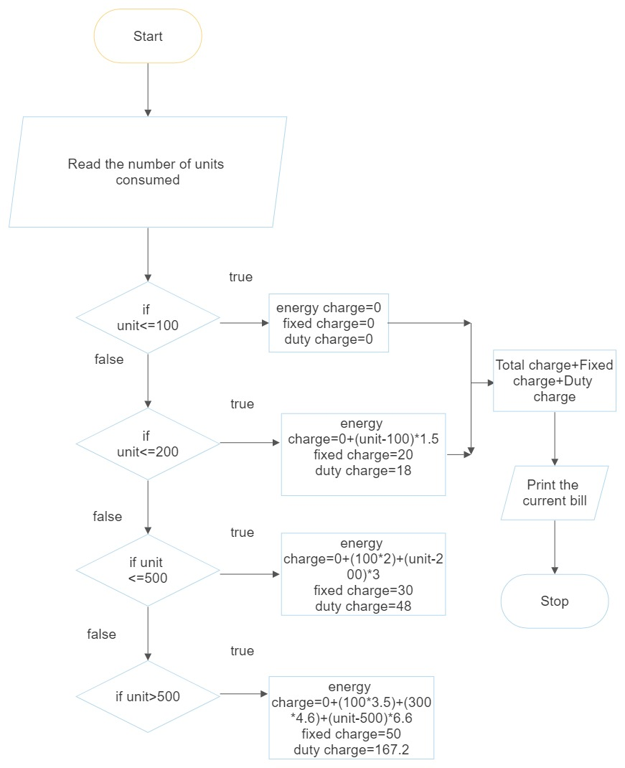

**RESULT:**

Thus the algorithm and flowchart is written for the given program

**WEIGHT OF IRON ROD**

**AIM**:

To draw the flowchart and write the algorithm for the iron rod

**ALGORITHM:**

Step 1: start

Step 2: read the diameter D and length of the iron rod L

Step 3: initialize i=0 and total = 0

Step 4: check if the value I is less than n

Step 5: if the condition is true

Step 6: calculate the weight of iron rod

Step 7: if the condition is false

Step 8: print the weight of the iron rod

Step 9: stop

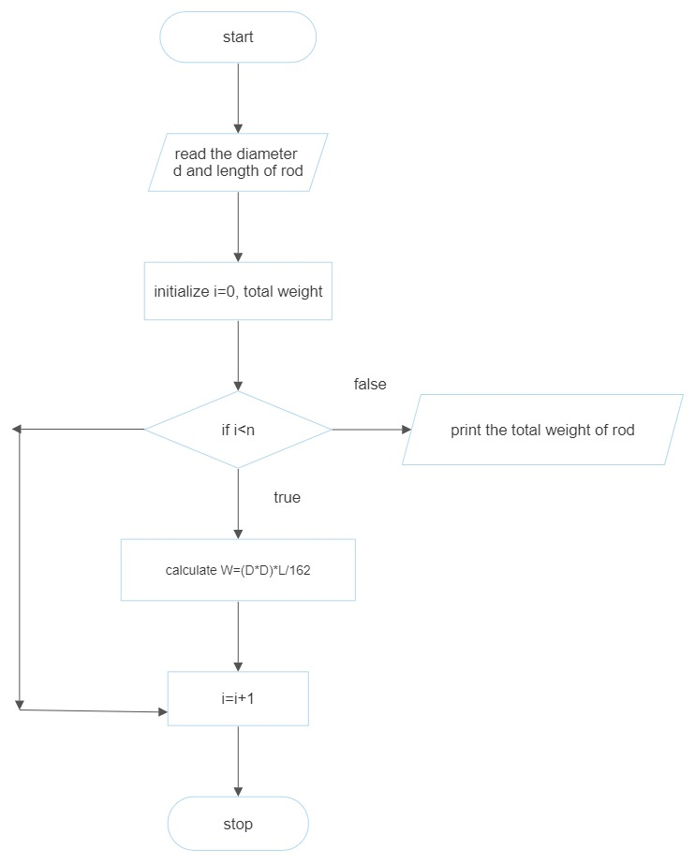

**RESULT:**

Thus the flowchart and algorithm is written for the given program

**WEIGHT OF THE MOTOR BIKE**

**AIM:**

To draw the flowchart and algorithm for the weight of the motor bike

**ALGORITHM:**

Step 1: start

Step 2: read the gross vehicle weight rating GVWR

Step 3: read the value of dry weight

Step 4: read the value of fuel weight

Step 5: read the value of rider weight

Step 6: read the value of passenger weight

Step 7: calculate the total weight of the motor bike

Step 8: get the load weight in variable weight

Step 9: calculate the load weight of the vehicle by adding

Step 10: calculate the safe weight by subtracting

Step 11: check the condition if the safe weight is greater than or equal to zero

Step 12: if the condition is true, print ” you are appreciated for safe journey”

Step 13: if the condition is false, print ”reduce for the weight for safe journey”

Step 14: stop

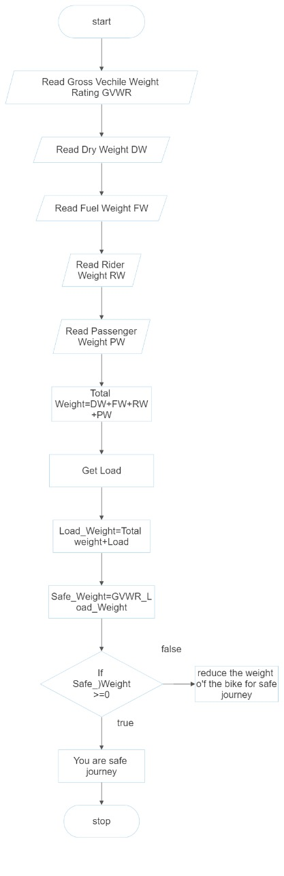

**RESULT:**

Thus the algorithm and flowchart is written for the given program

**RETAIL SHOP BILLING**

**AIM:**

To draw the flowchart and algorithm for the retail shop billing

**ALGORITHM:**

Step 1: start

Step 2: read the total number of the items

Step 3: initialize I = 0, total=0

Step 4: check condition I <=n:

Step 5: if condition is true, read the product name, no of items, price

Step 6: calculate total

Step 7: enter the discount of the items

Step 8: calculate the discount total

Step 9: calculate the net total

Step 10: if condition is false, read the GST value

Step 11: calculate the GST amount

Step 12: calculate the net price

Step 13: print the net price

Step 14: stop

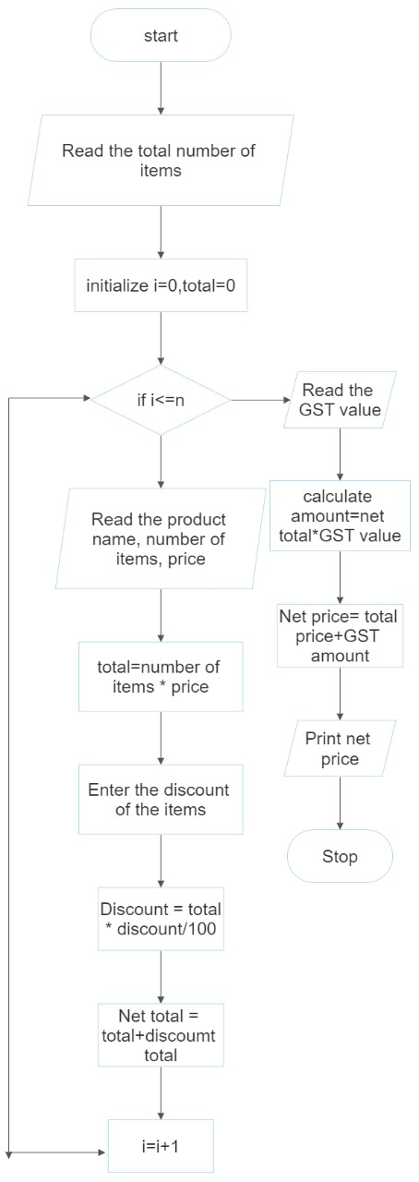

**RESULT:**

Thus the algorithm and flowchart written for the given program

**COMPUTING ELECTRICAL CURRENT IN 3 PHASE AC CIRCUIT**

**AIM:**

To draw the flowchart and write the algorithm for the given program

**ALGORITHM:**

Step 1: start

Step 2: read voltage, resistance, current, power factor

Step 3: calculate the electric current

Step 4: print electric current

Step 5: stop

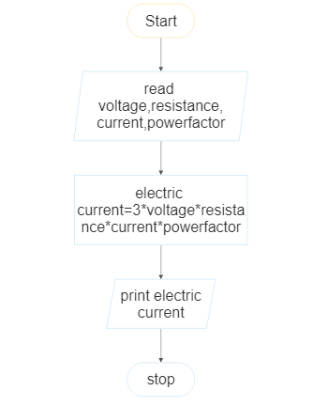

**RESULT:**

Thus the flowchart and algorithm written for the given program

**STUDENT GRADE ANALYSIS**

**AIM:**

To draw the algorithm and flowchart for the given program

**ALGORITHM:**

Step 1: start

Step 2: read the marks m1, m2, m3

Step 3: calculate the total

Step 4: calculate the average

Step 5: check for condition average > 30 and average<50

Step 6: if condition is true

Step 7: print “ your grade is C”

Step 8: check for condition average>50 and average<70

Step 9: if condition is true

Step 10: print” your grade is B”

Step 11: check for condition average>70 and average<100

Step 12: if condition is true

Step 13: print” your grade is A”

Step 14: check for condition average <30

Step 15: if condition is true

Step 16: print ”sorry, you can fail”

Step 17: stop

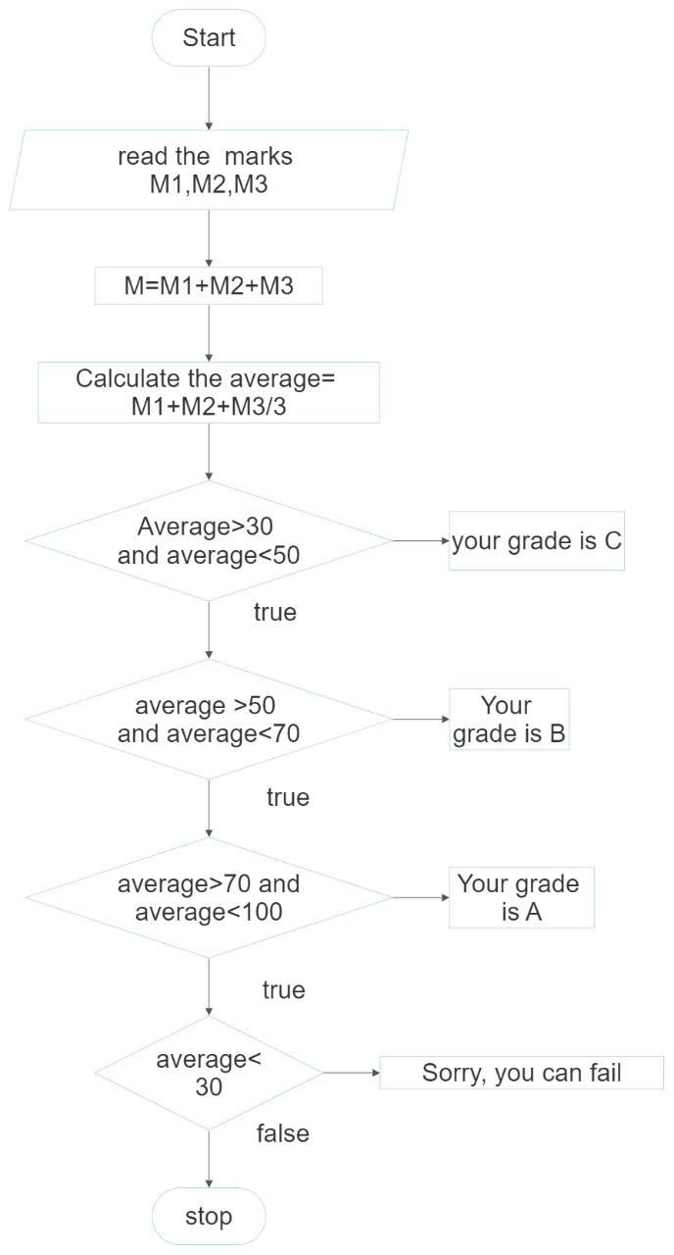

**RESULT:**

Thus the algorithm and flowchart is written for given program

**SINE SERIES**

**AIM**:

To draw the flowchart and algorithm for the sine series

**ALGORITHM:**

Step 1: start

Step 2: read the value of x

Step 3: initialize the value of I = 1, sine=0 and import math

Step 4: read the value of n

Step 5: check the value of I < n:

Step 6: if condition is true

Sine+(y*2*i+1))/ math .factorial (2+i+1)*s increment value of I by 1

Step 7: if condition is false

Step 8: print ”sine series”

Step 9: stop

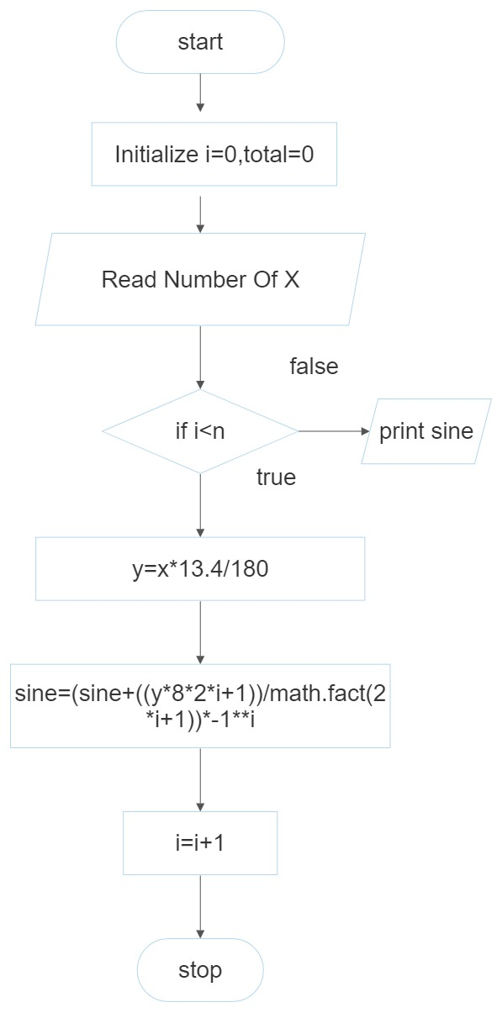

**RESULT:**

Thus the algorithm and flowchart is written for the given program